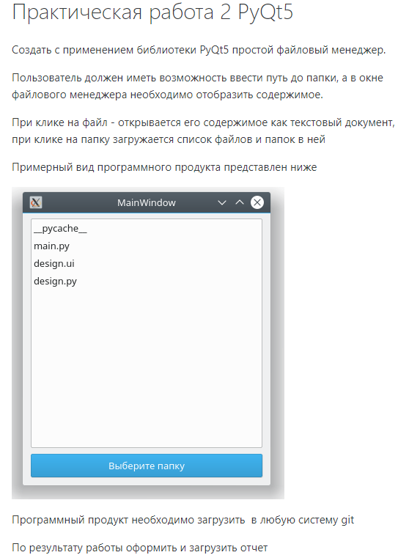

from PyQt5 import QtCore, QtGui, QtWidgets,QFileDialog

import sys

import os

class Ui_MainWindow(object):

dirlist=''

def setupUi(self, MainWindow):

MainWindow.setObjectName("MainWindow")

MainWindow.resize(800, 600)

self.centralwidget = QtWidgets.QWidget(MainWindow)

self.centralwidget.setObjectName("centralwidget")

self.listWidget = QtWidgets.QListWidget(self.centralwidget)

self.listWidget.setGeometry(QtCore.QRect(30, 10, 501, 351))

self.listWidget.setObjectName("listWidget")

self.Button = QtWidgets.QPushButton(self.centralwidget)

self.Button.setGeometry(QtCore.QRect(210, 430, 181, 71))

self.Button.setObjectName("Button")

MainWindow.setCentralWidget(self.centralwidget)

self.menubar = QtWidgets.QMenuBar(MainWindow)

self.menubar.setGeometry(QtCore.QRect(0, 0, 800, 26))

self.menubar.setObjectName("menubar")

MainWindow.setMenuBar(self.menubar)

self.statusbar = QtWidgets.QStatusBar(MainWindow)

self.statusbar.setObjectName("statusbar")

MainWindow.setStatusBar(self.statusbar)

self.retranslateUi(MainWindow)

QtCore.QMetaObject.connectSlotsByName(MainWindow)

def retranslateUi(self, MainWindow):

_translate = QtCore.QCoreApplication.translate

MainWindow.setWindowTitle(_translate("MainWindow", "MainWindow"))

self.Button.setText(_translate("MainWindow", "Open File"))

self.Button.clicked.connect(self.open_file)

self.listWidget.itemClicked.connect(self.Click_doc)

#self.listWidget.itemSelectionChanged.connect(self.Click_doc)

def open_file(self):

self.dirlist = QtWidgets.QFileDialog.getExistingDirectory()

print(self.dirlist)

for filename in os.listdir(self.dirlist):

print(filename)

self.listWidget.addItem(filename)

def Click_doc(self, item):

text = item.text()

self.listWidget.clear()

fname = self.dirlist + '/' + text

f = open(fname, 'r')

with f:

data = f.read()

self.listWidget.addItem(data)

'''

Очитчитть лист

открыть файл по полному пути\

вывести содержимое

'''

if __name__ == "__main__":

app = QtWidgets.QApplication(sys.argv)

MainWindow = QtWidgets.QMainWindow()

ui = Ui_MainWindow()

ui.setupUi(MainWindow)

MainWindow.show()

sys.exit(app.exec_())